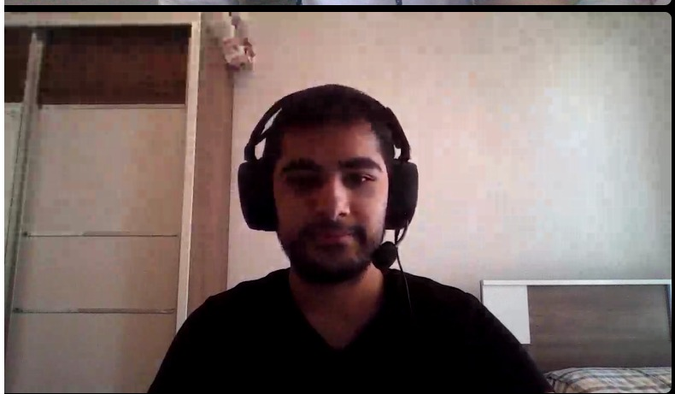

Fatih Bıçkı born in 3 March 2000. He grew up in Antalya as a smallest kid in family with one brother and one sister.

After he graduated from middle school he started to his high school education at Göynük Fen Lisesi.

He attended to various tournements of table tennis and chess while he was in high school.

He successfully completed his high school education in 2018.

He decided to continue his education in computer engineering at Adnan Menderes University because of passion he have from childhood to computers and how they work.

For his recent 3 years in university as student, he kept improve his skills with courses from internet and good-know university's online courses.

He learned the importance of ethically working as a engineer from his teachers.

His goal for future is become a world wide engineer.